Experiment : 7
Date:

STATE CHART DIAGRAM

AIM:
To study and represent the Library Management System book issuing process using a state/activity diagram and to observe how the system transitions between different stages such as book enquiry, availability checking, member validation, and book issuing.

OBJECTIVES:
Understanding System Behaviour
To understand the dynamic behaviour of a library management system.
Identifying System States
To identify different states involved in the book issuing process.
Analysing System Flow
To analyse how the system moves from one state to another based on conditions.
Improving System Design Understanding
To understand how diagrams help in designing efficient software systems.

PROBLEM STATEMENT:
In a library environment, issuing books requires several steps such as verifying book availability, validating member information, and checking the borrowing limit. If these processes are not organized properly, it may lead to confusion and inefficiency. Therefore, a structured representation using a state/activity diagram is required to clearly show the sequence of operations and decision points involved in issuing a book.

REQUIREMENTS:
Hardware Requirements
- Computer or Laptop
- Minimum 4 GB RAM
- Processor with basic computing capability
Software Requirements
- Operating System (Windows / Linux / MacOS)
- Flowchart Designing Tool (StarUML / Draw.io / Lucid chart / MS Visio)
- Basic text editor or documentation tool

BACKGROUND OF THE SYSTEM:
Libraries maintain large collections of books and manage many members. Traditionally, these operations were handled manually, which often resulted in delays and errors. With the help of software systems, these processes can be automated and organized effectively.
State diagrams or activity diagrams help in visualizing the workflow of the system. They provide a clear understanding of how the system behaves when different events occur.

INTRODUCTION:
A State Chart Diagram is used to represent the dynamic behaviour of a system. It shows how the system moves between different states depending on events or conditions.

These diagrams help in understanding:
- System states
- Transitions between states
- Conditions affecting the system
- Overall workflow of the system
They are widely used in software engineering and system design.

PLANNING:
* Identifying the System Process
The first step in planning is to identify the operations involved in the book issuing process such as enquiry, checking availability, member validation, and issuing the book.

*Identifying Decision Points
The system must make certain decisions during the process:
- Whether the book is available
- Whether the member is valid
- Whether the member has reached the borrowing limit

* Defining System Outputs
The system should produce the following outputs:
- Book issued successfully
- Book not available
- Book cannot be issued due to limit

OBSERVATION OF THE DIAGRAM:
The diagram represents the process of issuing a book in a Library Management System. The process begins with the enquiry about books by a user. The system first checks the availability of the requested book in the library.
If the book is not available, the system displays a message indicating that the book is not available and the process ends. If the book is available, the system proceeds to validate the library member.
During the validation stage, the system checks whether the user is a registered member of the library. If the user is not a valid member, the system performs the member registration process. After successful registration, the process continues.
If the member is valid, the system checks the number of books already issued to that member. Libraries usually set a limit on the number of books that can be borrowed at a time.
If the member has already reached the maximum borrowing limit, the book will not be issued. If the member is eligible and the limit has not been reached, the system proceeds to issue the book.
After issuing the book, the system records the member details, book details, and issue information in the system database. Finally, the book status is updated to reflect that the book has been issued.
The process then reaches the final state, indicating the completion of the book issuing operation.

SYSTEM DESIGN:
System design focuses on organizing the steps involved in issuing books. The design includes the logical structure of the system and the flow of operations.
The main components of the system include:
* User Enquiry
The user searches or enquires about a specific book.
* Availability Checking
The system verifies whether the book is available in the library.
* Member Verification
The system checks if the user is a registered library member.
* Member Registration
If the user is not registered, the system allows the user to register.
* Book Limit Checking
The system verifies whether the member has reached the maximum number of issued books.

* Book Issuing
If all conditions are satisfied, the book is issued to the member.
* Updating Database
The system records the issue details and updates the book status.

SYSTEM DESCRIPTION:
The Library Book Issue System manages the process of issuing books to library members. The process begins when a user makes an enquiry about a book in the library.
The system first checks whether the requested book is available. If the book is not available, the system displays a message stating that the book cannot be issued.
If the book is available, the system verifies whether the user is a valid library member. If the user is not a registered member, the system allows the user to register as a new member.
After validating the membership, the system checks the number of books already issued to the member. Libraries usually set a limit on the number of books a member can borrow at a time.
If the member has reached the maximum limit, the system does not issue the book. Otherwise, the system issues the book successfully.
The system then records the issue details such as member information and book details. Finally, the system updates the status of the book in the database.
STATE CHART DIAGRAM OF LIBRARY MANAGEMENT:
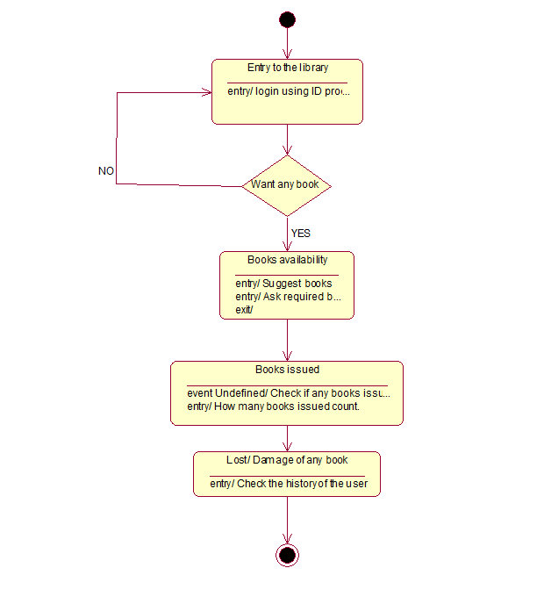

ADVANTAGES OF STATECHART DIAGRAM:
1. Clear Representation of System Behaviour
2. Helps in Understanding Dynamic Systems
3. Easy Visualization of States and Transitions
4. Improves System Design
5. Better Communication Among Developers
6. Helps in Debugging and Testing
7. Useful for Event-Driven Systems

LIMITATIONS:
- Large systems may produce complex diagrams
- Updating diagrams frequently may require extra effort
- Not suitable for representing very detailed algorithms
CONCLUSION:
The observation of the Library Management System diagram provides a clear understanding of how the system handles the process of issuing books. The diagram shows the different states, decision points, and transitions involved in the process. Such diagrams help software developers design efficient systems and ensure smooth functioning of library operations.

